Frontend Development
Project Documentation – Fitness Companion

1. Introduction:

Project Title: FitFlex: Your Personal Fitness Companion
Team ID:NM2025TMID34275
Team Leader: Sivadhurkka K (ksivadhurkka@gmail.com)

Team Members:

1. Mathumithral B S (mathumithral412@gmail.com)
2. Antony stephen A (antonystephen598@gmail.com)

2. Project Overview:

Purpose: The purpose of Fitness Companion is to provide users with an interactive platform to track workouts, follow exercise routines, monitor nutrition, and stay motivated with progress tracking.

Features:

- User authentication and profile management

- Workout tracker with daily/weekly routines

- Nutrition logs and calorie tracking

- Progress charts and analytics

- Personalized fitness recommendations

3. Architecture:

Component Structure: Includes components such as Dashboard, Workout Tracker, Nutrition Log, Progress Charts, and User Profile.

State Management: Using Context API (or Redux if required) to manage user data, routines, and progress tracking across components.

Routing: Implemented using React Router for navigation between pages like Home, Workouts, Nutrition, Profile, and Dashboard.

4. Setup Instructions:

Prerequisites: Node.js, npm or yarn

Installation:

Clone the repository

Run npm install inside the client directory

Configure environment variables (API keys for backend and external integrations if any)

5. Folder Structure:

Client: Organized into /components, /pages, /assets, /context, and /hooks.

Utilities: Custom hooks for handling authentication, API calls for fitness data, and helper functions for calculations (e.g., BMI, calories burned).

FitFlex/
│-- code/ # Main project folder
│ │-- db/ # Database configuration
│ │-- node_modules/ # Installed dependencies
│ │-- public/ # Static files
│ │-- src/ # Source code
│ │-- assets/ # Media assets (images, icons, etc.)
│ │-- components/ # React components
│ │-- pages/ # Pages (Dashboard, Login, etc.)
│ │-- App.css
│ │-- App.jsx
│ │-- main.jsx
│ │-- .gitignore
│ │-- package.json
│ │-- vite.config.js
│-- README.md

6. Running the Application:

Frontend: Run npm start inside the client directory to start the app locally.
● Backend: npm start → Runs on: http://localhost:5000

7. Component Documentation:

Key Components:

WorkoutTracker – Manages exercise routines and logs

NutritionLogger – Enables food tracking and calorie count

ProgressChart – Displays analytics of workouts/nutrition

UserProfile – User details and personal settings

Reusable Components: Buttons, Modals, Input Fields, Cards

8. State Management:

Global State: Tracks user session, fitness progress, and preferences.

Local State: Handles form inputs, modal toggles, and UI interactions locally within components.

9. User Interface:

Screenshots or mockups of the dashboard, workout logging panel, and progress charts.

10. Styling:

CSS Frameworks/Libraries: Using Tailwind CSS (or Styled Components) for flexibility.

Theming: Light/Dark theme support for user accessibility.

11. Testing:

Testing Strategy: Unit and integration tests with Jest and React Testing Library.

Code Coverage: Ensure at least 80% coverage using coverage reports.

12. Screenshots or Demo:

Provide UI previews of workouts, nutrition tracking, and progress statistics.
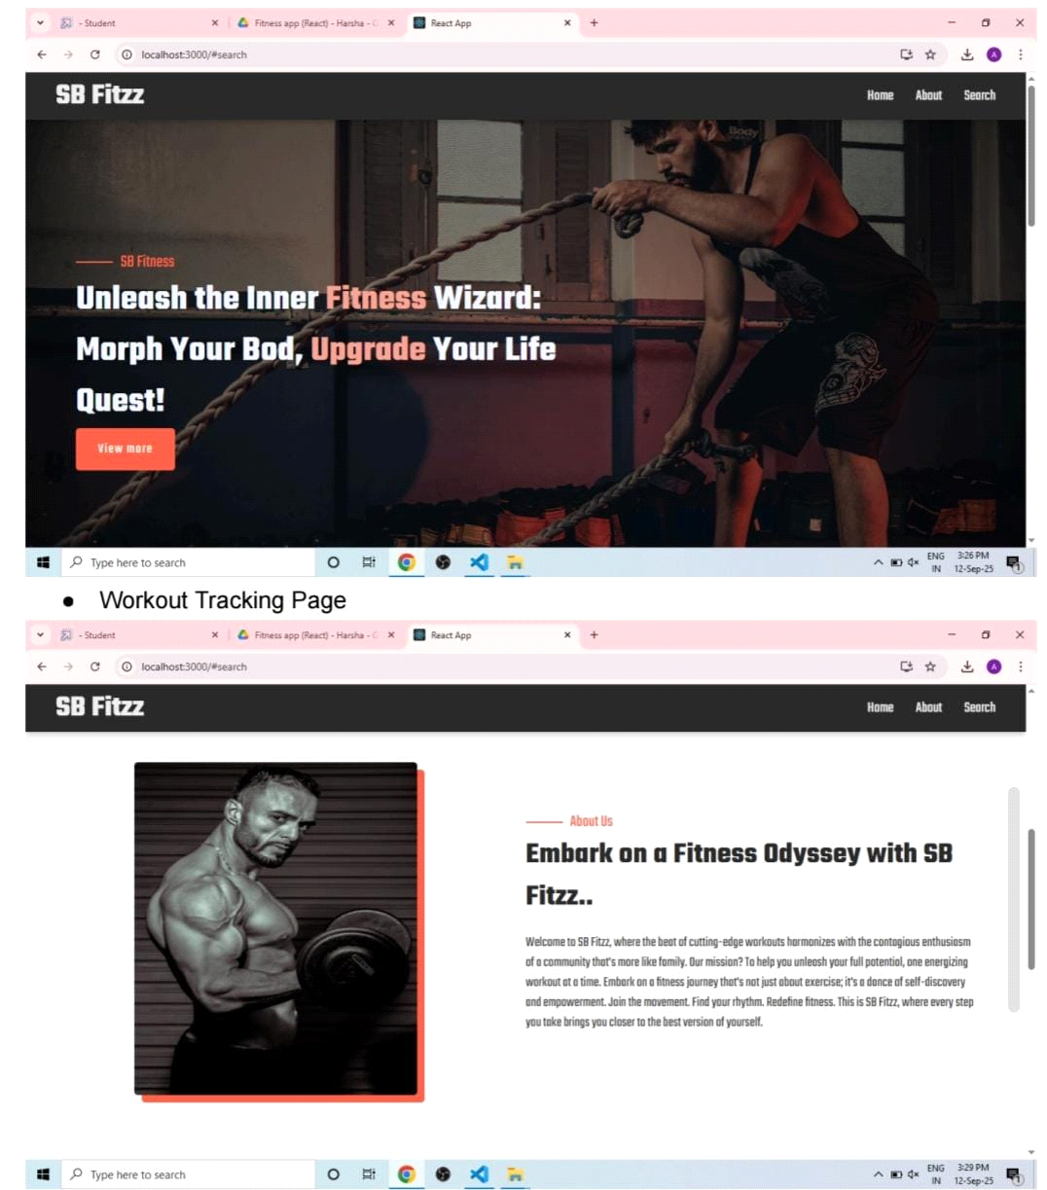

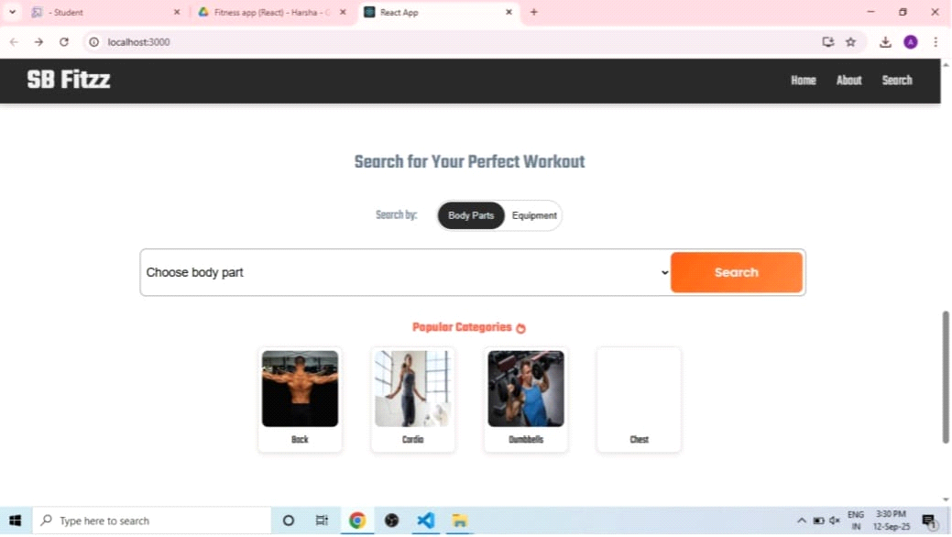

13. Known Issues:

API integration with external nutrition databases may cause delays.

Charts may not render properly on small screens.

14. Future Enhancements:

AI-generated workout/nutrition suggestions

Gamification with badges and levels

Social sharing of fitness progress

15. Technologies Used:

● React.js
● Node.js
● Express.js
● MongoDB
● JWT Authentication
● Visual Studio Code
● Git & GitHub

